Welcome

to Whitesburg Swim Team

New Parent & Swimmer Info.

Swim Meets of the Season

* **Time Trials** – At Time Trials, your swimmer will be timed in each of the four strokes they are able to do to set a baseline for the rest of the swim season. These times will be used to determine who will swim in the events at the first Dual Meet. New swimmers will also learn about what to expect at the first Dual Meet. Time Trials typically take place the Saturday morning before the first Dual Meet and last about 1½ hours.
* **Dual Swim Meets** – Dual Swim Meets are between two teams from the same league (A,B, or C) within the Rocket City Swim League, These meets take place on Wednesday nights, always the four Wednesdays in June plus the last Wednesday in May OR the first Wednesday in July (Tuesday if falls on July 4th). These meets last about 4 ½ hours from warm-ups to finish. Swimmers are welcome to leave after they complete their event(s).
* **City Meet** – City Meet is a league-wide meet in which all 18 teams in the Rocket City Swim League meet to compete for their place in the league the following year. This is an exciting event that had 1,300+ participants in 2017. City Meet typically takes place the second weekend of July, and if your swimmer does well in the Dual Meets or rounds out a relay, please plan to be there!
* **Throughout June**, there are a few fun (but optional) **Invitational Meets** open to all swimmers. These are a great way for swimmers to try to improve their seed times in strokes they do not usually swim at the Dual Meets. The Swim Rep will keep you informed of dates and registration information.

Volunteering

**REF, STARTER, STROKE & TURN JUDGES** – Those positions require certification.

**SCORING/COMPUTER TABLE HELPER** – This person assists the meet manager in collecting race results and staying organized.

**PLACE CALLER JUDGE** – The Place Caller Judge sits on the side of the pool at the finish end and watches as the swimmers finish. He calls out the lane number as each swimmer finishes (for example, 4,3,5,6,1,2). There are two Callers, one from each team, on each side of the pool, doing the same thing.  
 **SCRIBE** – The Scribe writes down what the Caller calls out.

**HEAD TIMER & TIMERS** – Each timer is assigned one lane to time the swimmer and write down his time. The head timer is a back-up in case any timer has an issue.

**RUNNER** – The runner takes time cards from the timers and place judges to the scoring table.

**PINKS AND BLUES** – Each event has a designated index card with the swimmer’s name, lane and event on it (one card for relays). The Pinks and Blues person works with the bullpen volunteers and hands the cards to our team’s swimmers (or coaches for 6U, 8U, and 9/10) as they come to swim their race. The swimmer (or coaches) will then hand his card to the timer when it’s time for him to swim.

**BULL PEN** – These 3-4 people help get the younger kids to their races. The Bull Pen workers will have a copy of the heat sheet and will call the kids names to get them together and to their starting position. You do not have to know the kids names to do this! This is a great way to meet the kids and learn their names. The kids will be in the bullpen or near the bullpen with their families. The 6U and 8U will start at the deep end of the pool because they only swim 25 yards. Swimmers age 9+ start at the shallow end. In a short time, swimmers will know how to get their card and go to their lane. The coaches will be at the shallow end helping and cheering.

**CONCESSIONS LEAD**– At home meets, this person helps set-up concessions (tables, ices drinks, etc.), works the first part of the first shift, and closes concessions at the end of the meet. They will also fill-in for other workers while they watch their swimmer’s events.

**CONCESSIONS** – At home meets, we will have concessions in the basketball area. We will sell entree plates, drinks, and snacks. You will be able to leave the concessions area to watch your swimmer swim. There are two shifts – 5:30 to 7:15 and 7:15 to end. Concessions will begin closing at 8:45.

Before You Come to the Meet: Marking Your Swimmer

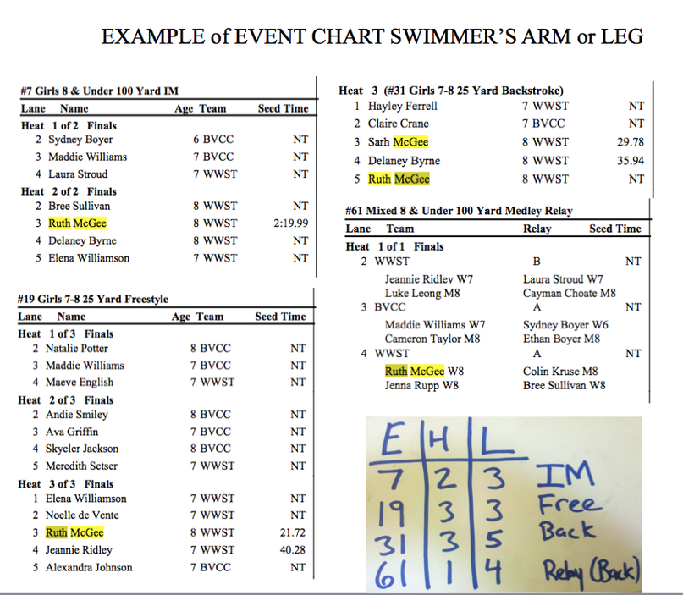**Step 1: Mark the Heat Sheet** – The heat sheet lists every event in the meet in order. It includes the number of the event as well as the distance, gender, age, and type of event (e.g., 25 yard freestyle). The number of heats, lane, name of the swimmer, age, team, and seedtime will be listed next.

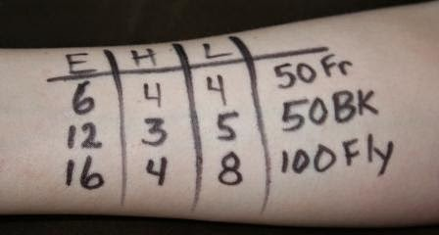**Step 2: On your swimmer’s left arm, make three columns with "E," "H," and "L."** Under the "E," put the swimmer's events in order. Under the "H," write the heat number that corresponds with their event. Under the "L," write the lane assignment that corresponds with the event. The last column will be the stroke that corresponds with their race. The correct way to read the column is left to right in rows.

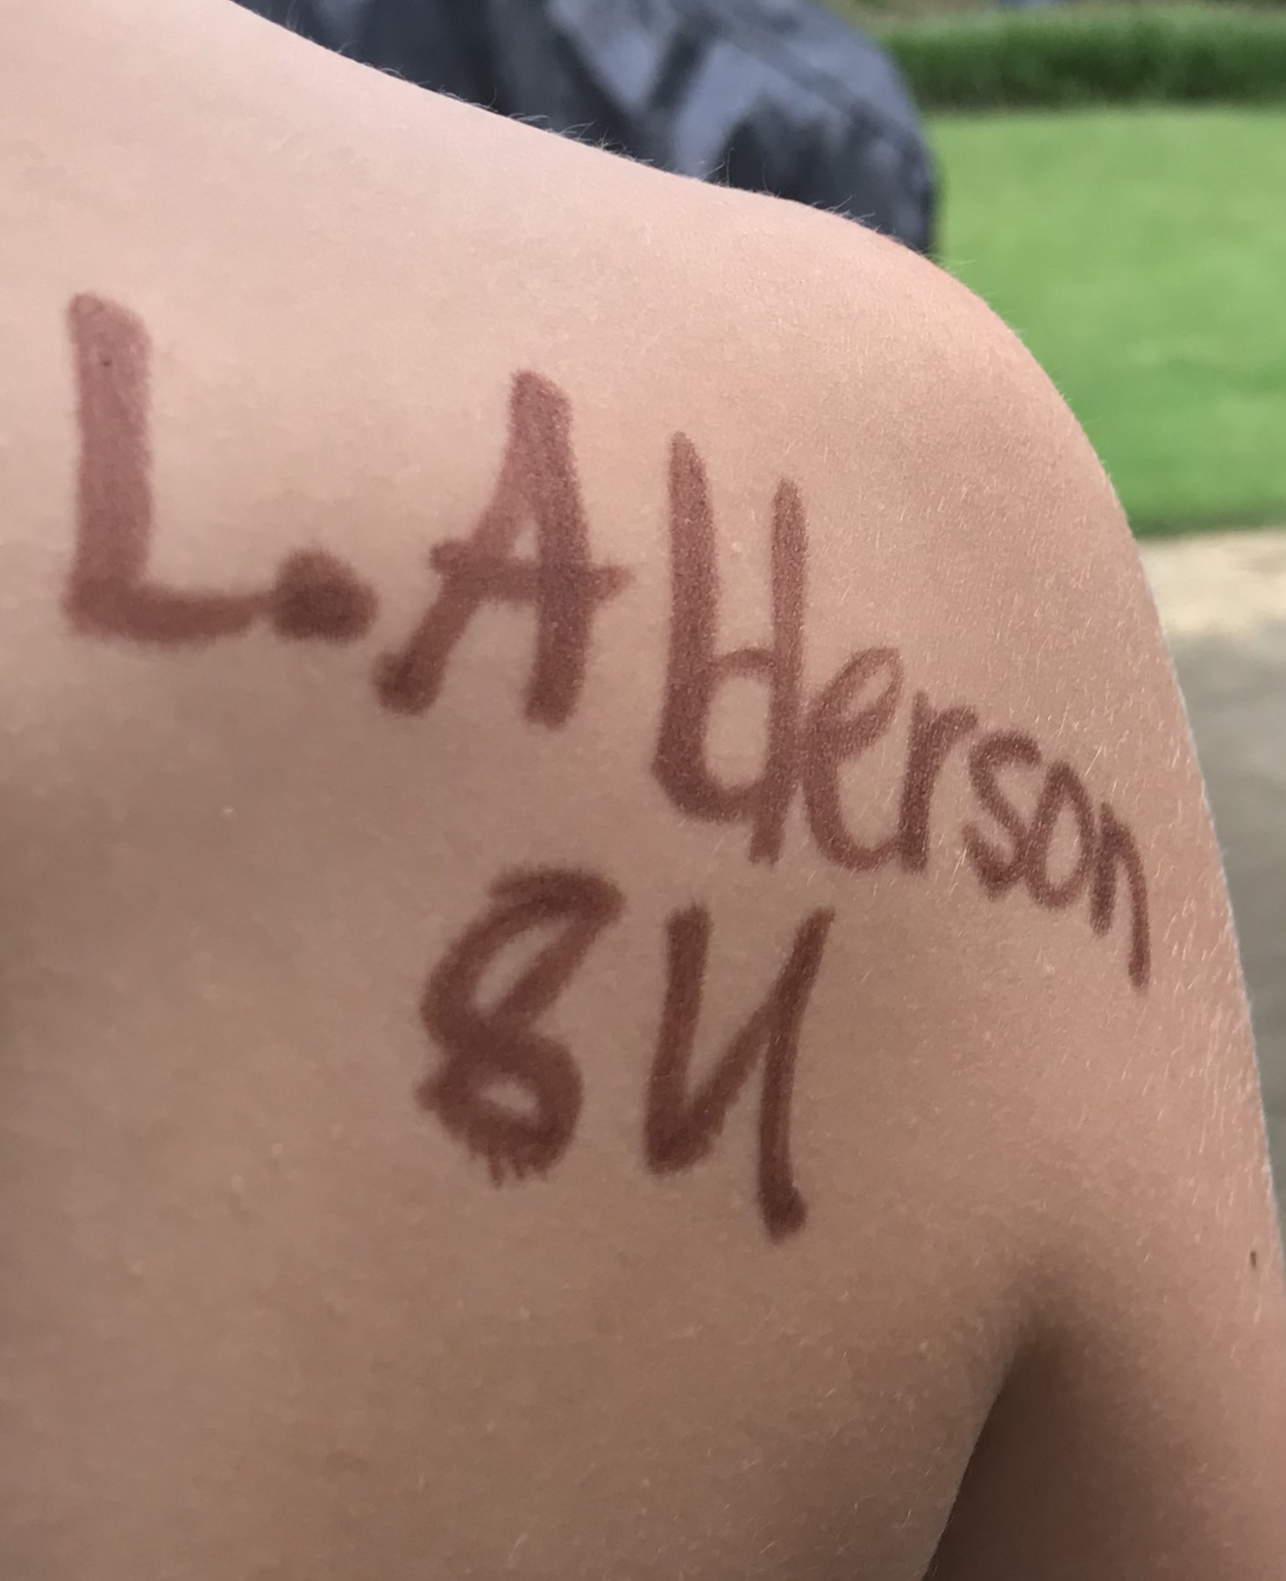

**Step 3: Write swimmer's first initial, last name, and age group (6U, 8U, 9/10 or 11/12) on their right shoulder.** This helps the bullpen worker identify your child.

**Step 4: Your swimmer needs to stay in the bullpen until his/her events are complete**. Even though the information is written on their arm, that does not mean swimmers will keep up with their events. Swim meets can be very exciting and swimmers easily lose track of time. There is a lot of time waiting between events, so encourage your swimmers to listen and not keep asking the coaches or bullpen workers if it is time for their event yet. The bullpen workers will help alert swimmers when their event is about to take place. If your swimmer is new or under 10 years, try to sit close to the bullpen. After his/her events are finished, come to the bullpen to pick up your swimmer.

What to Bring / Wear to a Swim Meet

* Swim suit
* Towels- 2 per swimmer – towels get really wet between races
* Goggles
* Swim cap (Whitesburg team cap or plain color only)
* Heat sheet or meet entries (whichever is available)
* Sharpie – for writing swimmer’s name and events
* Sports chairs - Swim meets are VERY crowded. Bring your own chairs and try to limit your space to leave room for others.
* Water / Sports drink - to keep hydrated
* Snacks or small bills / quarters for concessions – eat carbs / something that won't upset possible nervous stomach.
* Small cooler - you are welcome to bring outside food/drink.

While all clothing changes should be made in the restrooms, make sure your swimmer   
DOES NOT leave belongings there. Keep belongings together in the bullpen or leave with a parent, label EVERYTHING, and leave valuables at home.

What to Do When You Arrive at the Pool (HOME MEETS)

* At home meets, Whitesburg parents and swimmers may sit on the east and west sides of the lower deck of the pool. We reserve the upper deck for visiting teams.
* Arrive early and get your seats set up. Seating is first come, first serve.
* For home meets, Whitesburg swimmers are the first to warm-up, so your swimmer will need to arrive with their swimsuit on and cap and goggles nearby.
* The coaches will call the swimmers to warm-up. When your swimmer is finished warming-up, make sure they get a snack and a drink and use the restroom before the meet begins. You should try your best to have your swimmers sit during the meet to save their legs especially if they are swimming in a lot of races. In the bullpen, they can sit with friends, and THAT IS ENCOURAGED!
* If you have a swimmer in the medley relays or if they are a 6&U swimmer, they need to head to the bullpen right as soon as the visiting teams finishes warm-ups.

What to Do When You Arrive at the Pool (AWAY MEETS)

* Ask your swim rep before the meet to see where visiting teams set up in case you are one of the first team members to arrive. The visiting team will also help you know where to sit.
* For away meets, warm-ups are just prior to the start of the swim meet. If you have a swimmer in the medley relays or a 6&U swimmer, they need to dry off, take a swig of drink, use the restroom if needed, and then go right back to bullpen.

Swim Meet Events

For first timers, swim meets can seem overwhelming and chaotic because there are so many events, and they are over so quickly - literally, seconds. Swimmers are divided by gender and age: 6U, 8U, 9/10, 11/12, 13/14, 15-17. Swimmers age up on their birthdays and may swim in their own age group or one level above. Whitesburg swimmers will be in lanes 4-6 of the pool at home meets. 6U and 8U start events at the deep end of the pool, and all other age groups start at the shallow end of the pool. Pinks and blues are index cards for every event/swimmer on which their times will be recorded by the lane timer and taken to the scoring table by the runner. Points are earned for 1st, 2nd, and 3rd place in each individual stroke event and 1st place only in relays. The following information will help you understand what is going on at the first meet and how to help your swimmer get where he/she needs to be:

**Events are numbered 1 to 96.** Except for the Mixed Freestyle Relay, odd # events are for girls, and even # events are for boys. The order of events is by age group starting with the youngest and according to relay/stroke:

**Events 1 through 10** - Medley Relay (ages 8U and up) - four swimmers who each swim one stroke for 25 yards (8U only) or 50 yards in relay style in the order of backstroke, breaststroke, butterfly, freestyle.

**Events 11 through 46** - Freestyle and Freestyle Exhibition - single sprint of freestyle (all ages) - each team may enter up to 3 swimmers who swim 25 yards (6U & 8U) or 50 yards. This is the fastest event of the meet!

**Events 47 through 56** - Breaststroke (ages 8U and up) - single sprint of breaststroke (ages 8U and up) - each team may enter up to 3 swimmers who swim 25 yards (8U) or 50 yards.

**Events 57 through 65** - Mixed Freestyle Relay (ages 8U and up) - four swimmers (two girls, two boys) who each swim freestyle 25 yards (8U) or 50 yards.

**Events 67 through 76** - Backstroke (ages 8U and up) - single sprint of backstroke (ages 8U and up) - each team may enter up to 3 swimmers who swim 25 yards (8U) or 50 yards.

**Events 77 through 86** - Butterfly (ages 8U and up) - single sprint of butterfly (ages 8U and up) - each team may enter up to 3 swimmers who swim 25 yards (8U) or 50 yards.

**Events 87 through 96** - Freestyle Relay (ages 8U and up) - four swimmers who each swim freestyle 25 yards (8U) or 50 yards. This is the fastest relay of the meet!

Swimming is all about time, so the fastest swimmers will be entered in each event. As the season progresses, your swimmers will improve! Encourage them by keeping up with their times and showing them how much better they are getting each week. It is rare for a swimmer to be good at every stroke. Usually, swimmers will have one or two that come more naturally. You can help them by encouraging them to focus on what they do best and try to fine tune their stroke as well as starts and turns. There are lots of videos online that can really help them with their form, starts, and turns.

During the Meet

* DO cheer your swimmer on!
* DO encourage good sportsmanship.
* DO pay close attention to the events to know when to send your swimmer to bullpen.
* DO teach your swimmers about pinks and blues. Swimmers 11 and up will be handed an index card by a volunteer with their name and their lane assignment. Train your swimmer to check their lane assignments and make sure they are correct. Timers will be checking as well. They will hold onto their index card until they are next to swim. Before their race is called, they will hand their card to the timer (the timer knows to ask for it and usually will). This is where their time will be recorded. Encourage your swimmer to ask the lane timer what their time was when they get out of the pool.
* DO reserve all questions, concerns and comments for coaches until a time that is not during a meet or during practice. If you have an urgent concern, please find a volunteer or the swim rep.
* DO have a blast!
* You can see meet results the day after the meet at [www.swimrcsl.org](http://www.swimrcsl.org).